New methodology to measure residual stresses based on FBG sensors

J E P C Ribeiro^{1,*}, P.M.G.P. Moreira¹, R Barbosa²
¹Instituto Politécnico de Bragança, 5300-253, Bragança, Portugal
²Faculdade de Engenharia, Universidade do Porto, 4200-465 Porto, Portugal

^{(*)}Email: jribeiro@ipb.pt

ABSTRACT
Residual stresses are locked-in stresses which exist in a structural part without the application of any service or other external loads. The effects of residual stress may be either beneficial or detrimental, depending upon the magnitude, sign, and distribution of the stress with respect to the in service applied loads. In most cases, residual stresses arise from the production process.
To mechanically measure residual stress, one must relieve the locked-in stress, allowing a sensor to register the strain change resulting from the stress relaxation. One of the most common methods to measure residual stresses is the hole drilling method, which can be considered almost non-destructive due to the hole's small diameter. Electrical strain gage rosettes are the sensors commonly used in this method. This type of sensor can be problematic when used in industrial environments. The present study focuses on developing a new methodology to replace these electrical sensors with fiber optic Bragg sensors, aiming to eliminate this drawback. The results obtained, particularly with the 3.2 mm length grating sensors, were encouraging. The residual stress profile aligns with the findings from the electrical sensors.

INTRODUCTION
The interest in knowing how residual stress affects a material's mechanical properties and structure is growing. The failure of a structure or mechanical component is not only due to externally applied loading, but residual stress is also an important parameter in this respect. Mechanically induced plasticity or thermal effects, as noted by Withers and Bhadeshia (2001), typically create them. Quantitative estimation of residual stresses is important for the safe performance of structural components (Venkitakrishnan et al., 2007).
To mechanically measure residual stress, one must relieve the locked-in stress, allowing a sensor to register the strain change resulting from the stress relaxation. One of the most common methods to measure residual stresses is the hole drilling method, which can be considered almost non-destructive due to the hole's small diameter (Mathar 1934). This method, a technique widely accepted for measuring residual stresses, involves drilling a small hole into the surface of a component at the center of a special strain gage rosette and measuring the relieved strains. This type of sensor can be problematic when used in industrial environments, mainly due to electrical noise and magnetic fields. This study aims to eliminate this drawback by developing a new methodology that replaces electrical sensors with fiber optic sensors, specifically fiber Bragg grating (FBG) sensors. After installation and residual stress measurements, this new type of sensor can also be used to monitor the strain loading of the component during service.

RESULTS
The structural element exhibiting residual stresses was a plate welded using MIG. Two fibre optic rosettes were designed and evaluated, each equipped with gratings measuring 1.6mm and 3.2mm. We also employed two identical electric strain gage rosettes for the sake of comparison. Figure 1 displays an intricate perspective of a Fibre Bragg Grating (FBG) rosette. Presented in Figure 2 are the results for the sensor length of 3.2mm in both the electrical and FBG rosette settings.

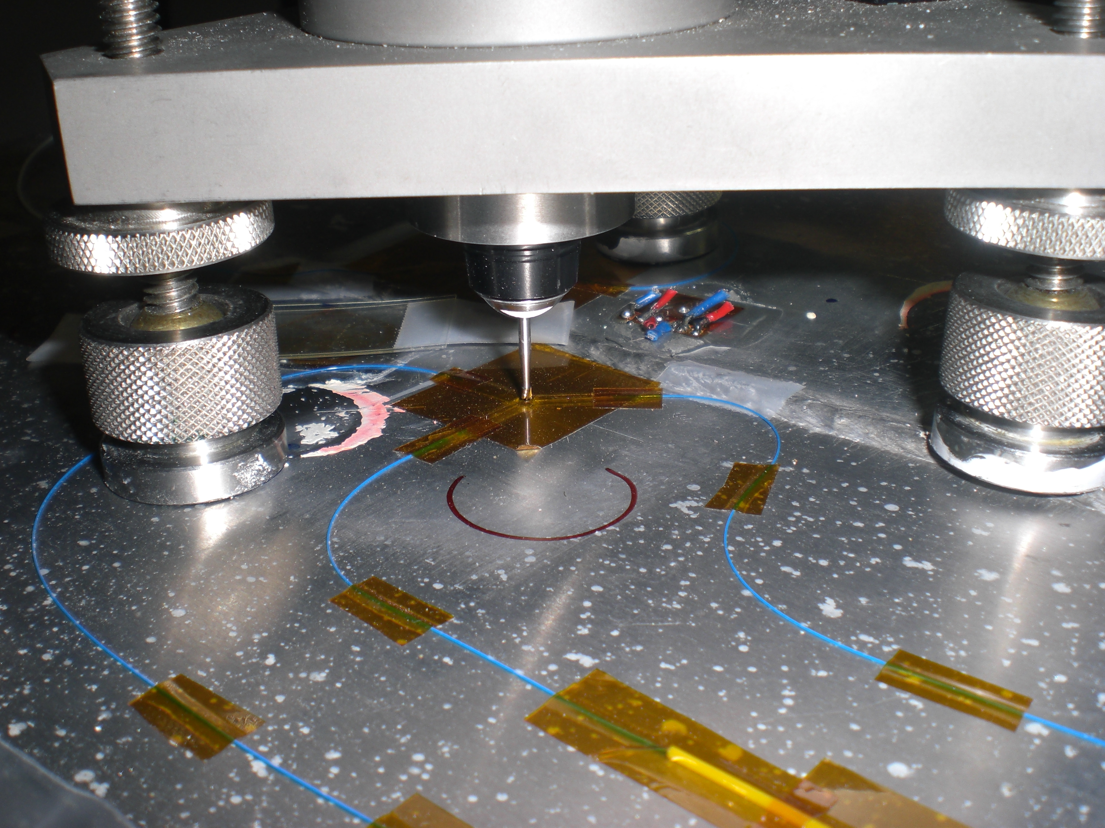 | 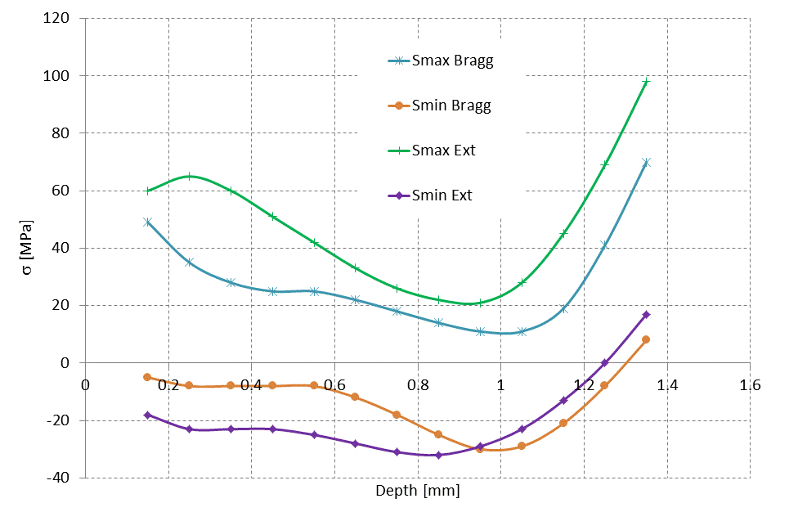
Figure 1- Experimental setup, fiber optical rosette. | Figure 2- Residual stress field, 3.2mm length sensors.

CONCLUSIONS
The results obtained, particularly with the 3.2 mm length grating sensors, were encouraging. The residual stress profile aligns with the findings from electrical sensors. New developments are being performed in order to improve the methodology already developed.

ACKNOWLEDGMENTS
P Moreira acknowledges POPH (Programa Operacional Potencial Humano) QREN (Quadro de Referência Estratégico Nacional) - Tipologia 4.2 promotion of scientific employment funded by the ESF (European Social Fund) and MCTES (Ministério da Ciência, Tecnologia e Ensino Superior). The support of Universidade do Porto Pluridisciplinar projects program is also acknowledge. The FBG sensors were kindly supplied by FiberSensing.

REFERENCES
Withers P. and Bhadeshia H., Overview - Residual stress part 2 - Nature and origins. Materials Science and Technology, 2001. 17(4): p. 366-375.
Venkitakrishnan P., Philip J., and Krishnamurthy R., An assessment of stresses in thin-walled welded tubes through hole drilling and sectioning methods. Journal of Materials Processing Technology, 2007. 185(1-3): p. 228-232.
Mathar J., Determination of Initial Stresses by Measuring the Deformation Around Drilled Holes. ASME Transactions, 1934. 56(4): p. 249-254.

