Contribution Title
First Author^{1,*}, Second Author² and Third Author¹
¹ Department/Research Centre, Institution, Postal Code, City, Country
² Department/Research Centre, Institution, Postal Code, City, Country
* Corresponding author: author@institution.pt
[Full papers must be written in English and contain 4–10 A4 pages, including the title, abstract, figures, tables, acknowledgements and references. Use this file directly and do not modify the page size, margins, fonts, header or footer. Delete all instructional text in square brackets before submission.]
Abstract. [Provide a self-contained summary of approximately 150–250 words. Briefly present the context and objective, the methods or approach, the most important quantitative or qualitative results, and the principal conclusion. Do not include citations, figures, tables or undefined abbreviations.]
Keywords: [three to five keywords; separated by semicolons]
[The structure below is recommended and may be adapted to experimental, numerical, review, educational, design-based or industrial contributions. Use no more than three numbered heading levels.]
1 Introduction
[Introduce the topic, establish its relevance to additive manufacturing and/or sustainability, and identify the scientific, educational or industrial problem addressed. Provide a focused review of the most relevant literature and clearly state the objective, research question or contribution of the paper.]
[The first paragraph after a heading is not indented. Cite references using consecutive numbers in square brackets, for example [1], [2, 3] or [4–6]. Every cited work must appear in the reference list.]
[Subsequent paragraphs use a first-line indentation. Avoid excessive background information and ensure that the final paragraph of the Introduction clearly presents the aims and, where appropriate, the organisation of the paper.]
1.1 Optional subsection
[Subsections may be used when they improve clarity. Keep headings concise and avoid creating a subsection containing only one short paragraph.]
[Use standard abbreviations only. Define each abbreviation at first use and use SI units throughout the manuscript.]
2 Materials and Methods / Methodology
[Adapt this heading to the type of contribution, for example: Materials and Methods, Methodology, Computational Approach, Review Method, Educational Design or Industrial Case Study.]
2.1 Materials, data or study context
[Describe the materials, equipment, software, datasets, participants, learning context, case-study setting or literature sources required to understand the work. Identify manufacturers, models and relevant specifications only when they affect reproducibility.]
[For experimental or numerical studies, report the relevant conditions and variables. For reviews, explain the databases, search terms, eligibility criteria and selection procedure. For educational studies, describe the participants, learning activities and assessment strategy, while respecting ethical and data-protection requirements.]
2.2 Procedures and analysis
[Explain the procedure with enough detail to allow replication or informed assessment. Include validation, uncertainty, statistical analysis, comparison criteria or performance indicators where applicable.]
[Equations should be introduced in the text, centred and numbered consecutively. Define all symbols immediately before or after the equation.]
E = mc² (1)
3 Results
[Present the results in a clear and logical sequence. Use tables and figures only when they add information; do not repeat the same numerical data in the text, a table and a figure. Report units, variability and uncertainty where relevant.]
[All tables and figures must be mentioned in the text before they appear. Number them consecutively using Arabic numerals.]
Table 1. Example of table formatting. Place the caption above the table and replace or delete this example.
Parameter | Description / condition | Unit | Result
[Parameter 1] | [Brief description] | [unit] | [value]
[Parameter 2] | [Brief description] | [unit] | [value]
[Parameter 3] | [Brief description] | [unit] | [value]
3.1 Figures and graphical results
[Use high-quality figures. Vector graphics are preferred for diagrams and line drawings; photographs and raster images should normally have a resolution of at least 300 dpi. Ensure that all labels remain legible at the final printed size and avoid text smaller than 8 pt.]

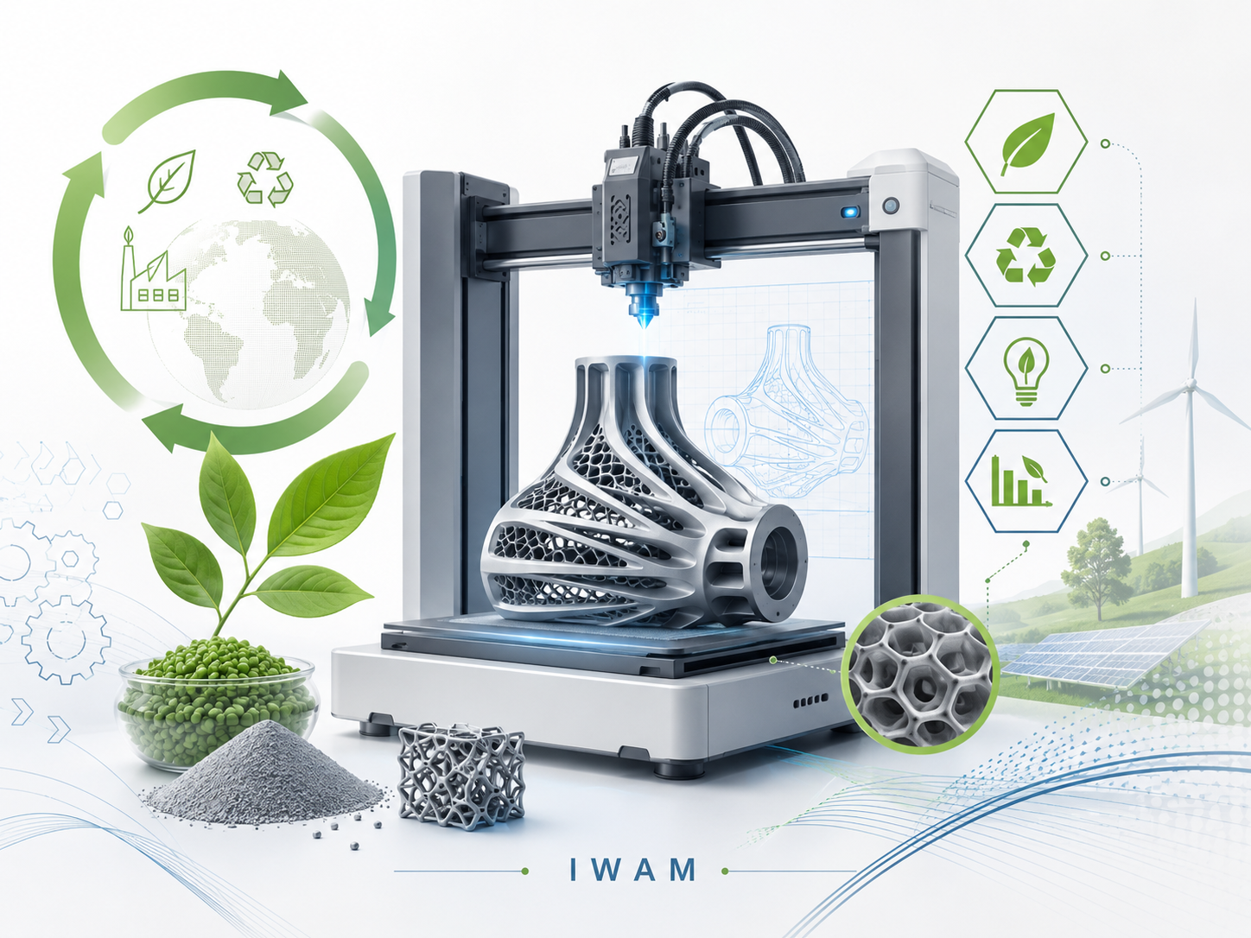
Figure 1. Example figure caption. Place the caption below the figure and explain all symbols, abbreviations and panels.
4 Discussion
[Interpret the results rather than restating them. Relate the findings to the objective and to previous research, explain their scientific or practical significance, and discuss limitations, uncertainties and conditions affecting generalisation. Results and Discussion may be combined into a single section when this improves clarity.]
[Where appropriate, discuss implications for resource efficiency, circularity, energy use, material performance, environmental impact, education, industrial implementation or future development.]
5 Conclusions
[Summarise the main findings and the original contribution of the work. The conclusions should answer the objective stated in the Introduction, avoid repeating the abstract and contain no new results or citations. Brief recommendations or future work may be included when directly supported by the study.]
Acknowledgements
[Optional. Identify funding bodies and grant or project numbers, institutional or technical support, shared facilities and contributions that do not meet the criteria for authorship. Delete this section when it is not applicable.]
Declarations
[Optional and subject to the requirements of the proceedings. State any competing interests, ethical approval, informed consent, data availability or use of generative AI tools when applicable. Delete headings that do not apply.]
Competing interests. [The authors declare no competing interests / describe any relevant competing interests.]
Data availability. [Indicate where supporting data are available, or explain justified restrictions.]
References
[List only works cited in the manuscript, in the order in which they first appear. Use consecutive numbers in square brackets and follow the examples below. Include the DOI whenever available and verify every bibliographic detail before submission.]
[1] A. A. Author and B. B. Author, “Title of the article,” Journal Name, vol. X, no. Y, pp. xx–yy, Year, doi: xx.xxxx/xxxxx.
[2] A. A. Author, B. B. Author, and C. C. Author, “Title of the contribution,” in Proceedings of the Conference Name, City, Country, Year, pp. xx–yy.
[3] A. A. Author, Book Title, xth ed. City, Country: Publisher, Year.
[4] A. A. Author, “Title of chapter,” in Book Title, A. Editor and B. Editor, Eds. City, Country: Publisher, Year, pp. xx–yy.
[5] Organisation, Standard or Technical Report Title, document no. xxxxx, Year.
[6] Organisation or Author, “Title of online resource,” Year. Accessed: Day Month Year. [Online]. Available: URL.
[Before submission, confirm that the complete manuscript contains between 6 and 10 pages and that all instructions, example content and unused sections have been removed.]

